Soldier survives attack; captures, medically treats sniper (Video)
During a routine patrol in Baghdad June 2, Army Pfc. Stephen Tschiderer, a medic, was shot in the chest by an enemy sniper, hiding in a van just 75 yards away. The incident was filmed by the insurgents.
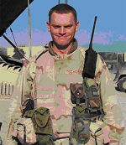
Pfc. Stephen Tschiderer is a native of Mendon, N.Y. —
Tschiderer, with E Troop, 101st “Saber” Cavalry Division, attached to 3rd Battalion, 156th Infantry Regiment, 256th Brigade Combat Team, 3rd Infantry Division, was knocked to the ground from the impact, but he popped right back up, took cover and located the enemy’s position.
After tracking down the now-wounded sniper with a team from B Company, 4th Battalion, 1st Iraqi Army Brigade, Tschiderer secured the terrorist with a pair of handcuffs and gave medical aid to the terrorist who’d tried to kill him just minutes before.

http://www.armytimes.com/story.php?f=1-292925-976420.php

